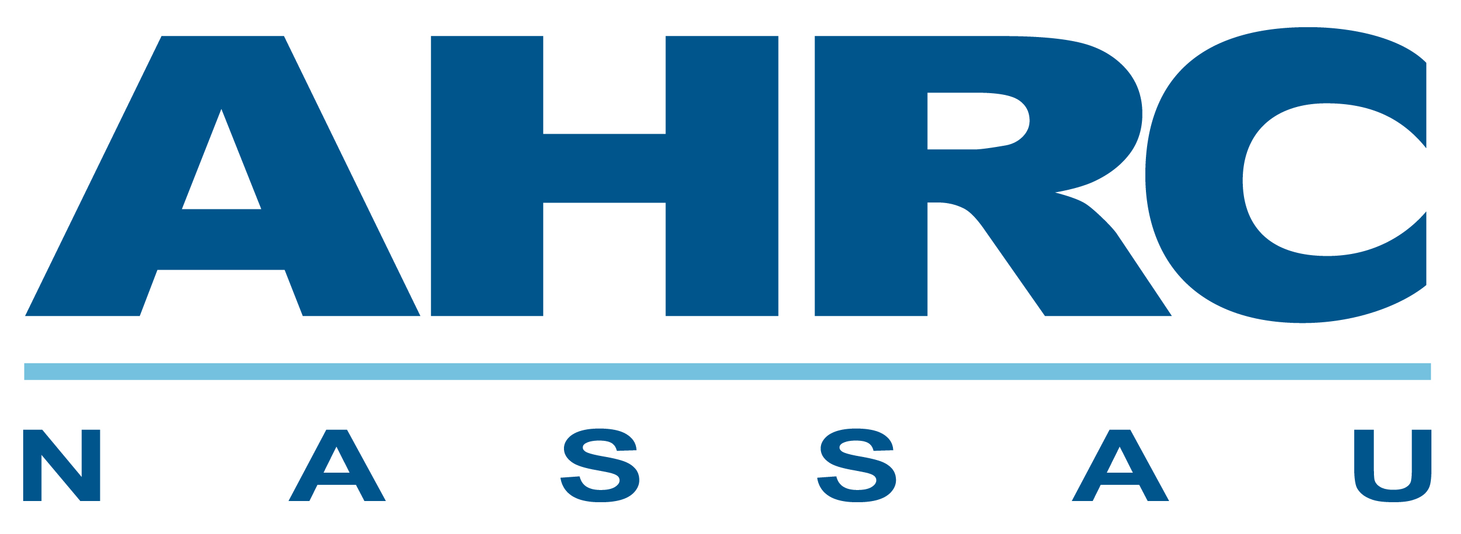

189 WHEATLEY ROAD, BROOKVILLE, NEW YORK 11545

AHRC ANNUAL MEETING - November 20, 2023 – 6:00 p.m.

AGENDA

- Welcome and Call to Order – Saundra M. Gumerove, Esq., President

- Approval of Minutes – November 21, 2022

- Report by President – Saundra M. Gumerove
Special Presentation – Brandon Klein, Jericho High School Senior

- Report by Chief Executive Officer - Stanfort J. Perry

- Reading of the 2024 Slate of Officers & Directors – Rose-Angela Marazita, Secretary

- Election

- Adjourn

